Instructions:

* Please no sharing information with other students.
* Instructor cannot assist on the exam
* The exam is open book
* If you complete the exam early, you may be dismissed

Good luck! There are 5 print screens/code copy, each worth 20%

**Project #1**

**Based on JFRAMES & INHERITANCE**

Complete the following question below, using a **JFrame** class

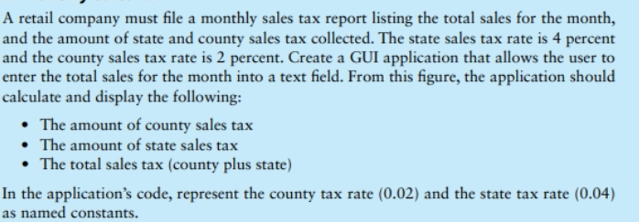

**#1 print screen the output below here for the county, state and total sales tax from the 1st frame**

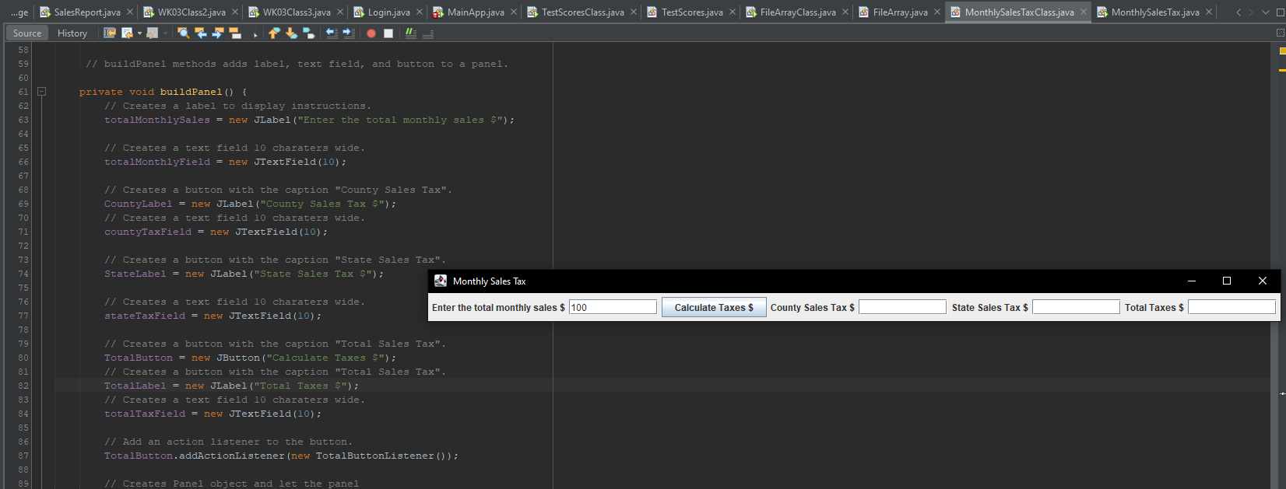

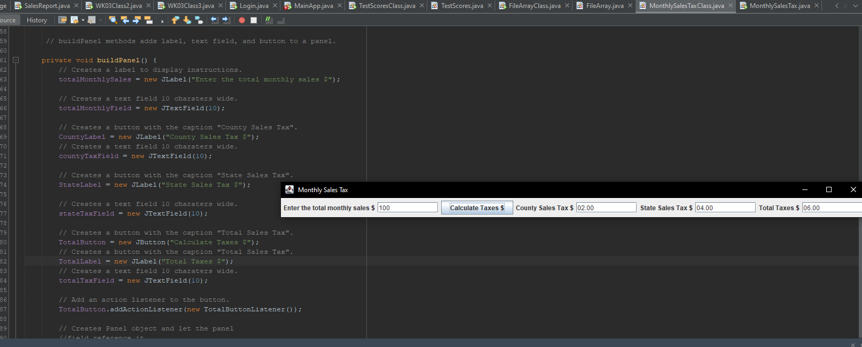

**#3 copy and paste the code below here**

**package week4;**

**import java.awt.FlowLayout;**

**import java.awt.event.ActionEvent;**

**import java.awt.event.ActionListener;**

**import java.text.DecimalFormat;**

**import javax.swing.JButton;**

**import javax.swing.JFrame;**

**import javax.swing.JLabel;**

**import javax.swing.JPanel;**

**import javax.swing.JTextField;**

**public class MonthlySalesTaxClass extends JFrame {**

**private JPanel panel;**

**private JLabel totalMonthlySales;**

**private JTextField totalMonthlyField;**

**private JTextField countyTaxField;**

**private JTextField stateTaxField;**

**private JTextField totalTaxField;**

**private JLabel CountyLabel;**

**private JLabel StateLabel;**

**private JLabel TotalLabel;**

**private JButton TotalButton;**

**private final int WINDOW_WIDTH = 400;**

**private final int WINDOW_HEIGHT = 200;**

**private final double COUNTY_TAX = .02;**

**private final double STATE_TAX = .04;**

**//Constructor**

**public MonthlySalesTaxClass() {**

**//Set the window title**

**setTitle(" Monthly Sales Tax ");**

**// Set the size of the window.**

**setSize(WINDOW_WIDTH, WINDOW_HEIGHT);**

**//Specify what happens when the close buttom is clicked.**

**setDefaultCloseOperation(JFrame.EXIT_ON_CLOSE);**

**//build Panel and add it to the frame.**

**buildPanel();**

**// Add the panel to he frame**

**add(panel);**

**// Sets the size of the window**

**pack();**

**// disply the window**

**setVisible(true);**

**}**

**// buildPanel methods adds label, text field, and button to a panel.**

**private void buildPanel() {**

**// Creates a label to display instructions.**

**totalMonthlySales = new JLabel("Enter the total monthly sales $");**

**// Creates a text field 10 charaters wide.**

**totalMonthlyField = new JTextField(10);**

**// Creates a button with the caption "County Sales Tax".**

**CountyLabel = new JLabel("County Sales Tax $");**

**// Creates a text field 10 charaters wide.**

**countyTaxField = new JTextField(10);**

**// Creates a button with the caption "State Sales Tax".**

**StateLabel = new JLabel("State Sales Tax $");**

**// Creates a text field 10 charaters wide.**

**stateTaxField = new JTextField(10);**

**// Creates a button with the caption "Total Sales Tax".**

**TotalButton = new JButton("Calculate Taxes $");**

**// Creates a button with the caption "Total Sales Tax".**

**TotalLabel = new JLabel("Total Taxes $");**

**// Creates a text field 10 charaters wide.**

**totalTaxField = new JTextField(10);**

**// Add an action listener to the button.**

**TotalButton.addActionListener(new TotalButtonListener());**

**// Creates Panel object and let the panel**

**//field reference it.**

**panel = new JPanel();**

**// Add the label, text field, and button**

**// components to the panel**

**panel.add(totalMonthlySales);**

**panel.add(totalMonthlyField);**

**panel.add(TotalButton);**

**panel.add(CountyLabel);**

**panel.add(countyTaxField);**

**panel.add(StateLabel);**

**panel.add(stateTaxField);**

**panel.add(TotalLabel);**

**panel.add(totalTaxField);**

**}**

**/\*\***

**\* calculateButton is an action listener class for the Calculate Button**

**\*/**

**private class TotalButtonListener implements ActionListener {**

**// This method executes when the user clicks on the Calculate Button**

**public void actionPerformed(ActionEvent e) {**

**String MonthlySalesInput;**

**double mSales;**

**double countyTax;**

**double stateTax;**

**double totalTax;**

**DecimalFormat formatter = new DecimalFormat("00.00");**

**// get the text entered by the user in the text field box**

**MonthlySalesInput = totalMonthlyField.getText();**

**// convert wholesale text to double**

**mSales = Double.parseDouble(MonthlySalesInput);**

**countyTax = (mSales * COUNTY_TAX); // Calculates the county tax**

**stateTax = (mSales * STATE_TAX); // Calculates the state tax**

**totalTax = (countyTax + stateTax);**

**// Formats retail price and converts to string text**

**String countyTaxS = formatter.format(countyTax);**

**String stateTaxS = formatter.format(stateTax);**

**String totalTaxS = formatter.format(totalTax);**

**// display the results**

**countyTaxField.setText(countyTaxS);**

**stateTaxField.setText(stateTaxS);**

**totalTaxField.setText(totalTaxS);**

**}**

**}**

**public static void main(String[] args) {**

**new MonthlySalesTaxClass();**

**}**

**}**

**package week4;**

**import java.awt.event.ActionEvent;**

**import java.awt.event.ActionListener;**

**import javax.swing.JButton;**

**import javax.swing.JFrame;**

**import javax.swing.JLabel;**

**import javax.swing.JOptionPane;**

**import javax.swing.JPanel;**

**import javax.swing.JTextField;**

**public class MonthlySalesTax extends JFrame**

**{**

**private JPanel panel;**

**private JLabel messageLabel;**

**private JTextField salesTextField;**

**private JButton calcButton;**

**private final double COUNTY_TAX_RATE = 0.02;**

**private final double STATE_TAX_RATE = 0.04;**

**/* Constructor */**

**public MonthlySalesTax()**

**{**

**// Sets window title**

**setTitle("Monthly Sales Tax Calculator");**

**// Specifies what happens when the close button is clicked.**

**setDefaultCloseOperation(JFrame.EXIT_ON_CLOSE);**

**// Build the panel and add it to the frame.**

**buildPanel();**

**// Adds the panel to the frame's content pane**

**add(panel);**

**// Sets the size of the window**

**pack();**

**// Display the window**

**setVisible(true);**

**}**

**// Adds a label, text field, and a button to a panel**

**private void buildPanel()**

**{**

**// Creates a label to display instructions**

**messageLabel = new JLabel("Enter the month's sales");**

**// Creates a text field 10 characters wide**

**salesTextField = new JTextField(10);**

**// Create a button with the caption "Calculate taxes".**

**calcButton = new JButton("Calculate");**

**// Add an action listener to the button.**

**calcButton.addActionListener(new CalcButtonListener());**

**// Creates a JPanel object and let the panel field reference it**

**panel = new JPanel();**

**// Add the label, text field, and button components to the panel.**

**panel.add(messageLabel);**

**panel.add(salesTextField);**

**panel.add(calcButton);**

**}**

**private class CalcButtonListener implements ActionListener**

**{**

**public void actionPerformed(ActionEvent e)**

**{**

**String input;**

**double countyTax, stateTax, totalTax;**

**// Store the user's input**

**input = salesTextField.getText();**

**// Calculates the different taxes**

**countyTax = Double.parseDouble(input) * COUNTY_TAX_RATE;**

**stateTax = Double.parseDouble(input) * STATE_TAX_RATE;**

**totalTax = countyTax + stateTax;**

**// Display the result**

**JOptionPane.showMessageDialog(null, "County sales tax: " + countyTax +**

**"\nState sales tax: " + stateTax + "\nTotal sales tax: " + totalTax);**

**}**

**}**

**public static void main(String[] args) {**

**new MonthlySalesTax();**

**}**

**}**

**Project #2**

**Based on Inheritance**

Create a class named **Employee** with the following information in fields:

* 1. Employee Name
  2. Employee Address
  3. Employee City
  4. Employee State
  5. Employee Zipcode

Next write a class named **ProductionWorker** that extends the Employee class. The *ProductionWorker* class should have the following information fields: *Shift*, and *Hourly* *Pay* *rate*, use a Scanner class to enter the information and output the fields from the *Employee* and *ProductionWorker* class from the main method. *Determine which class should be the main method class.*

**#4 print screen the output below here**

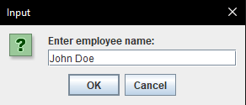

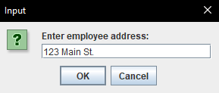

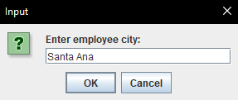

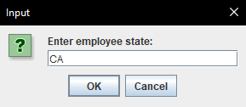

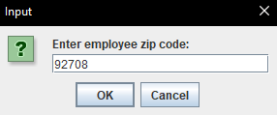

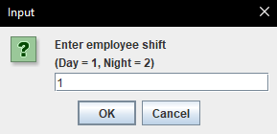

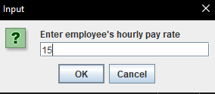

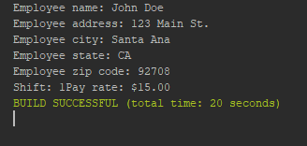

**#5 copy and paste the code below here**

**package week4;**

**class Employee {**

**public String eName, eAddress, eCity, eState, eZipCode;**

**public void setName(String n){**

**eName = n;**

**}**

**public void setAddress(String n){**

**eAddress = n;**

**}**

**public void setCity(String n){**

**eCity = n;**

**}**

**public void setState(String n){**

**eState = n;**

**}**

**public void setZipCode(String n){**

**eZipCode = n;**

**}**

**public String getName(){**

**return eName;**

**}**

**public String getAddress(){**

**return eAddress;**

**}**

**public String getCity(){**

**return eCity;**

**}**

**public String getState(){**

**return eState;**

**}**

**public String getZipCode(){**

**return eZipCode;**

**}**

**}**

**package week4;**

**import java.text.DecimalFormat;**

**import javax.swing.JOptionPane;**

**class ProductionWorker extends Employee{**

**private int shift;**

**private double payRate;**

**public void setShift(int i){**

**if(i!=1 && i!=2){**

**System.out.println("Invalid shift. Exiting program..");**

**System.exit(0);**

**}**

**shift = i;**

**}**

**public void setPayRate(double p){**

**payRate = p;**

**}**

**public int getShift(){**

**return shift;**

**}**

**public double getPayRate(){**

**return payRate;**

**}**

**public static void main(String[] args) {**

**DecimalFormat d = new DecimalFormat("$#,###,###.00");**

**ProductionWorker p = new ProductionWorker();**

**String input;**

**input = JOptionPane.showInputDialog("Enter employee name: ");**

**p.setName(input);**

**input = JOptionPane.showInputDialog("Enter employee address: ");**

**p.setAddress(input);**

**input = JOptionPane.showInputDialog("Enter employee city: ");**

**p.setCity(input);**

**input = JOptionPane.showInputDialog("Enter employee state: ");**

**p.setState(input);**

**input = JOptionPane.showInputDialog("Enter employee zip code: ");**

**p.setZipCode(input);**

**input = JOptionPane.showInputDialog("Enter employee shift\n(Day = 1, Night = 2)");**

**p.setShift(Integer.parseInt(input));**

**input = JOptionPane.showInputDialog("Enter employee's hourly pay rate");**

**p.setPayRate(Double.parseDouble(input));**

**System.out.println("Employee name: "+p.getName());**

**System.out.println("Employee address: "+p.getAddress());**

**System.out.println("Employee city: "+p.getCity());**

**System.out.println("Employee state: "+p.getState());**

**System.out.println("Employee zip code: "+p.getZipCode());**

**System.out.print("Shift: " + p.getShift());**

**System.out.println("Pay rate: "+d.format(p.getPayRate()));**

**System.exit(0);**

**}**

**}**

**Submit this document to Module 4**